1. Adding the GIT repo

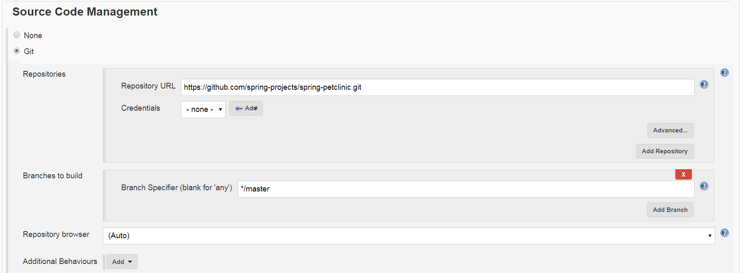

1. Adding build step to build package and store locally

